EC2 CHALLANGES
- Launch one EC2 instance using Amazon Linux 2.
In regular way launch a ec2 server
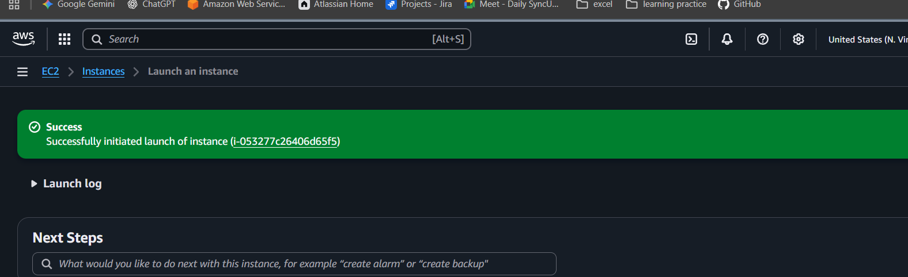
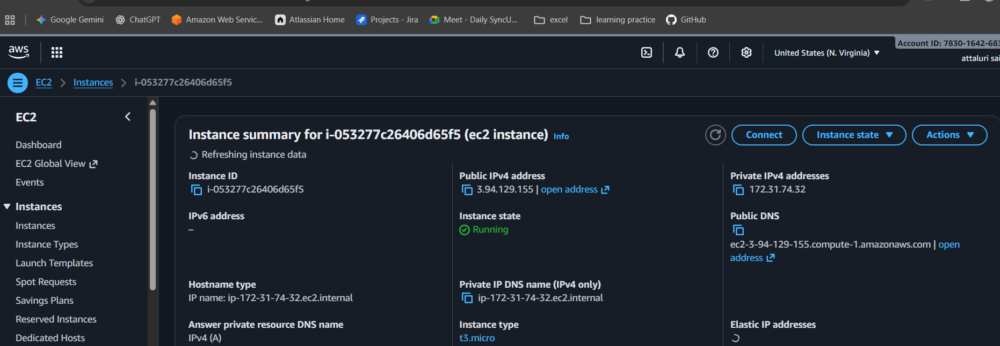

- Install Docker
step 1: change the user to root
step 2: install docker package using yum install docker
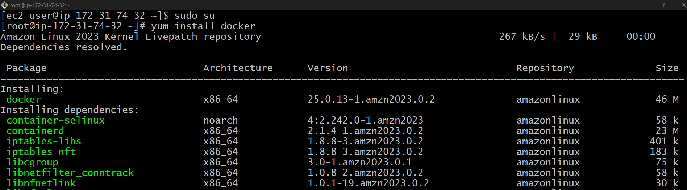

Step 3: verify the installation
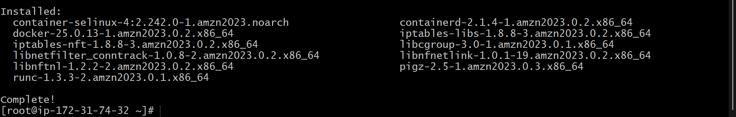
Step 4: use systemctl command to run and start the service
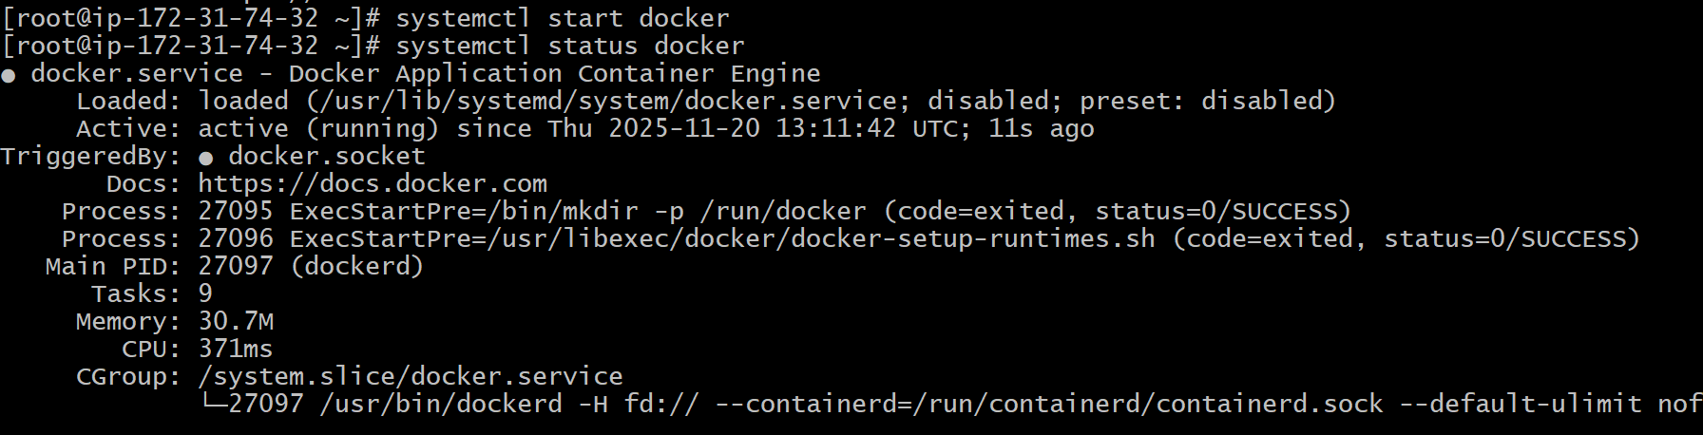

- Install Java
Step 1: command to download java in amazon linux is
Sudo yum install java-17-amazon-corretto -y
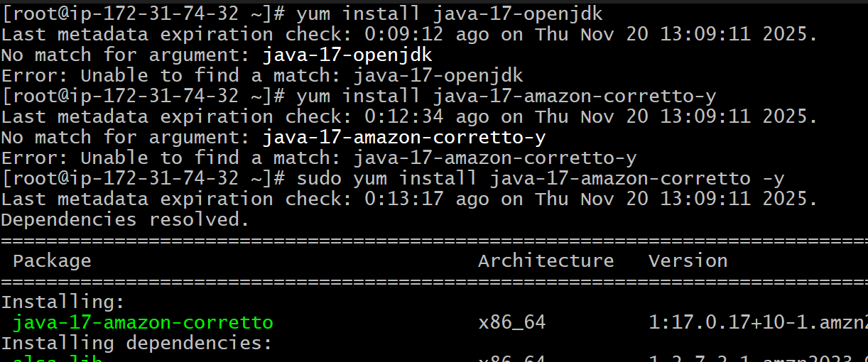
Step 4: verify the java version
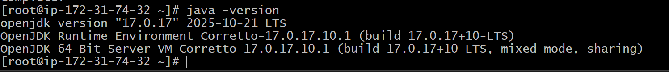

- Install Httpd (apache)
Step 1: use command sudo systemctl yum install httpd -y
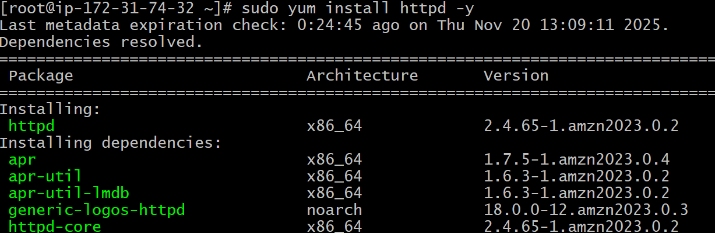
Step 2 : verify the service is running or not
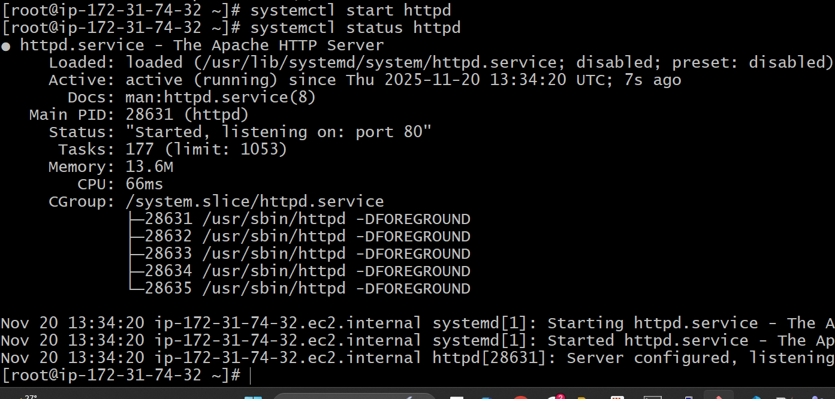
Step 3: verify in browser using ip:80
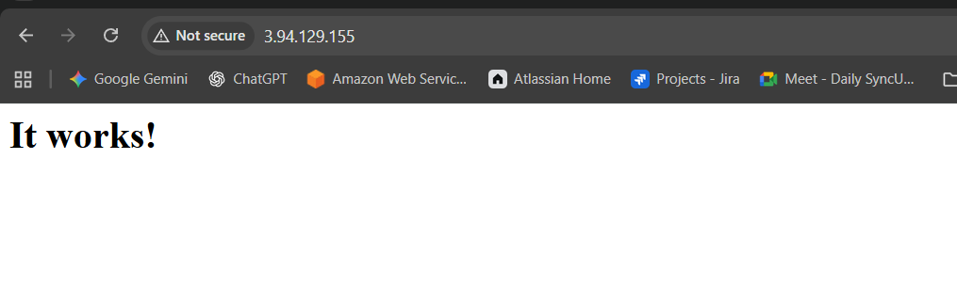

- Changing the httpd port number to 81 because httpd and nginx contains same port
Step 1: go to command vi /etc/httpd/conf/httpd.conf
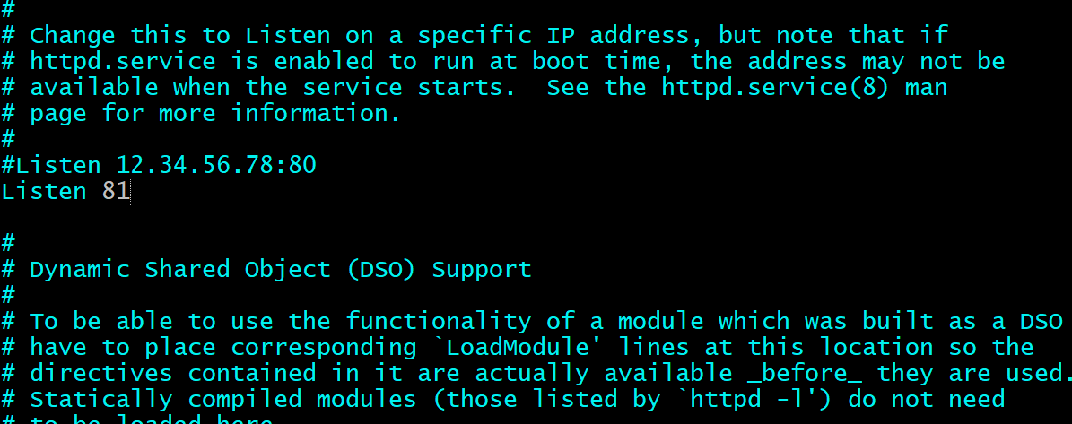
Step 2: restart the service
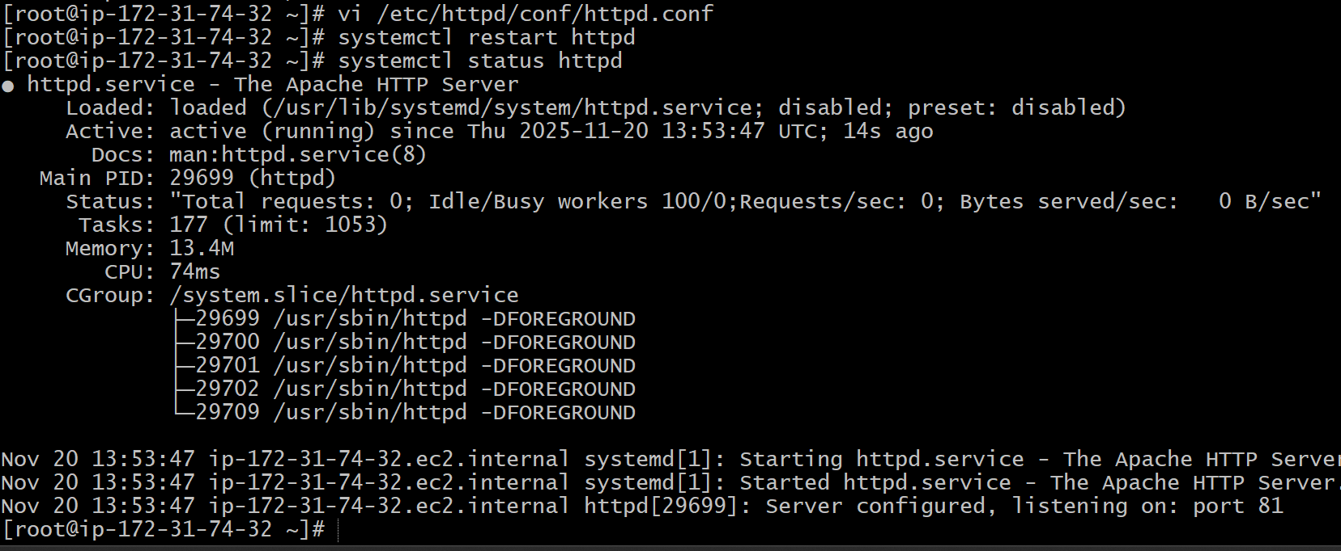
Step 3: verify on browser
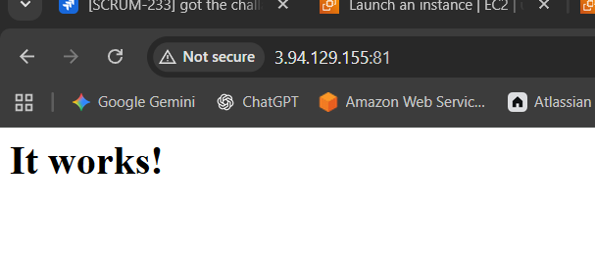

- Install Nginx
Step 1: yum install nginx -y
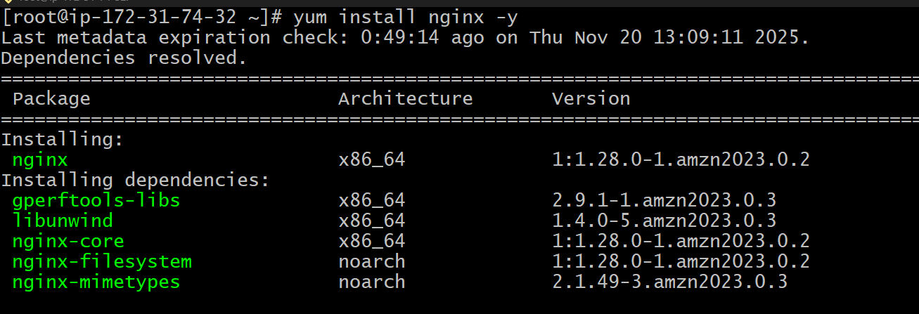
Step 2: restart the service and check the status
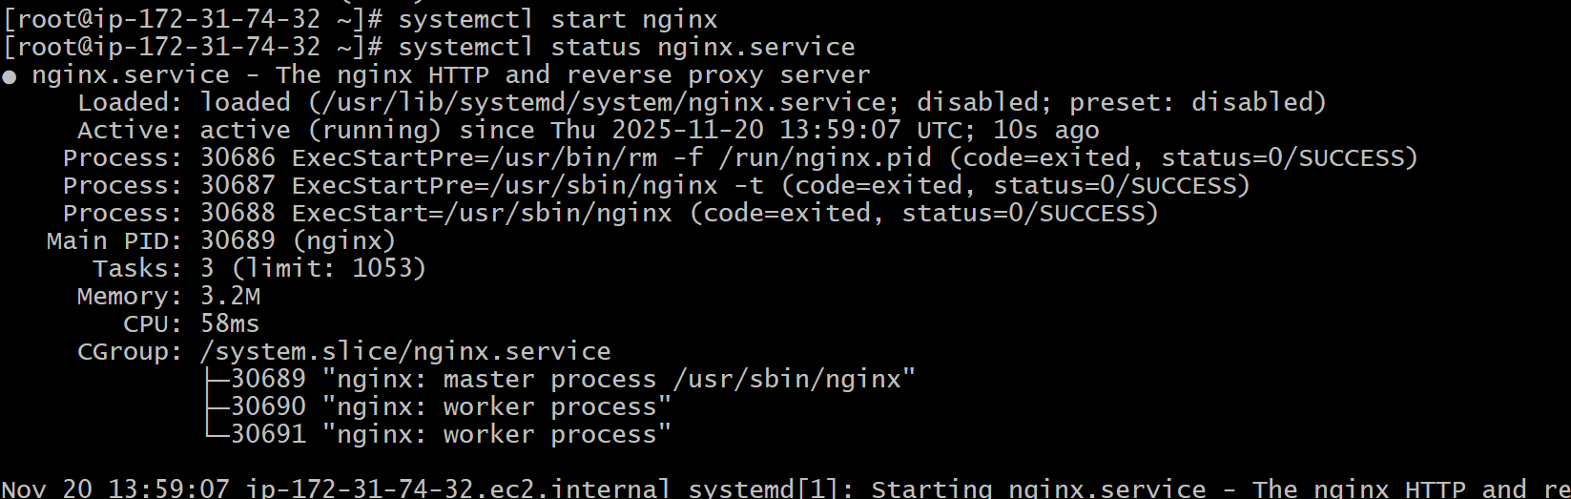
Step 3: verify on browser
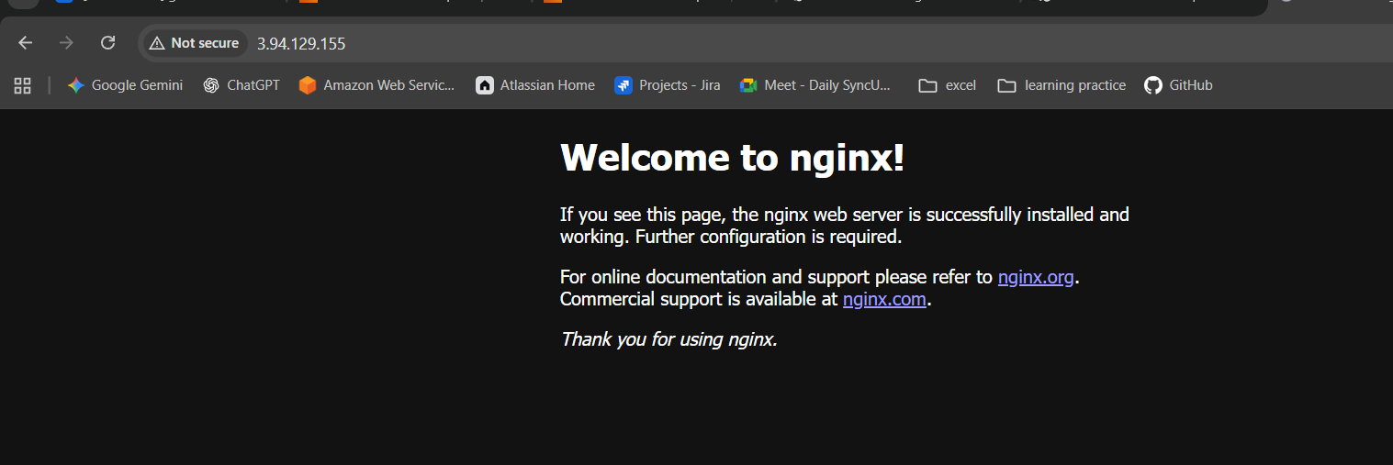

- Install Apache Tomcat.
Step 1: copy the link from apache tomcat website and paste it using wget/curl
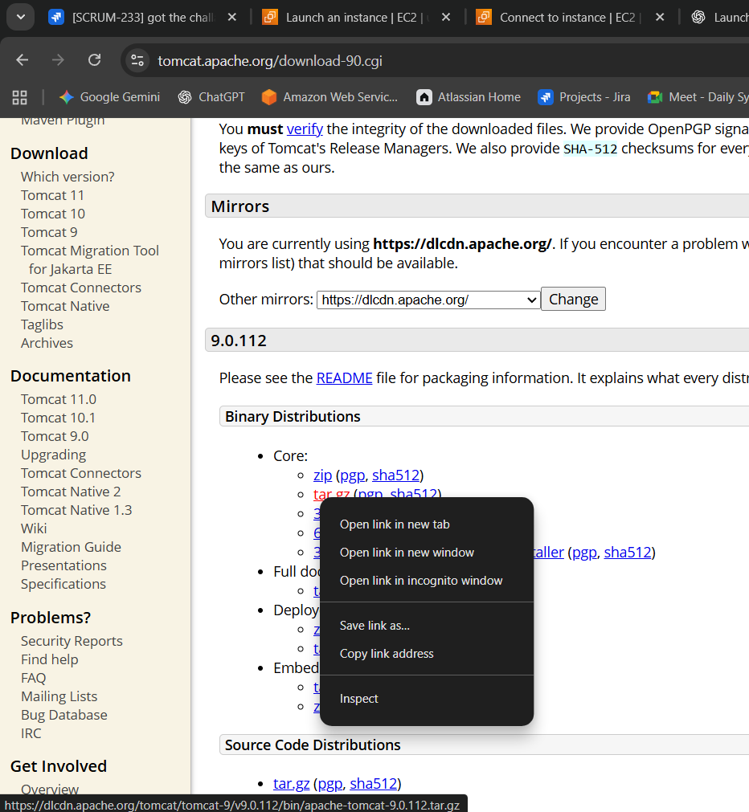
Step 2: execute the command wget
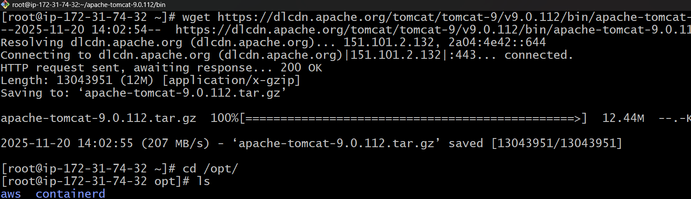
Step 3: extract the tar file using tar xvf apache-tomcat-9.0.112.tar.gz
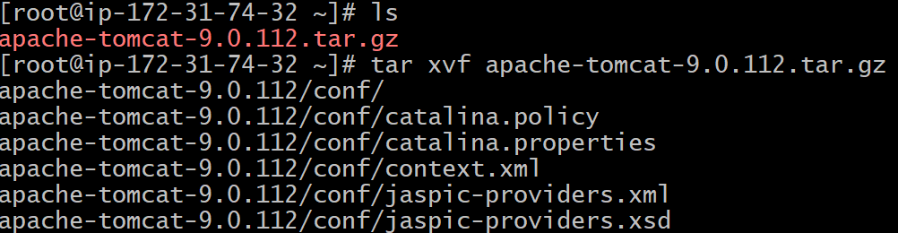
Step 4:list the files
Step 5: change directory to apache-tomcat-9.0.112/2 then list the files
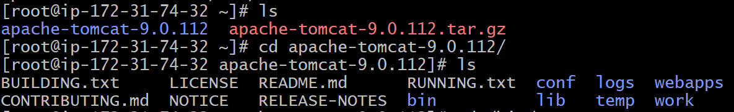
Step 6: change directory to apache-tomcat-9.0.112/bin
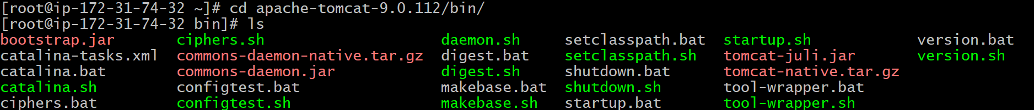
Step 7: run the command ./startup.sh to start the service
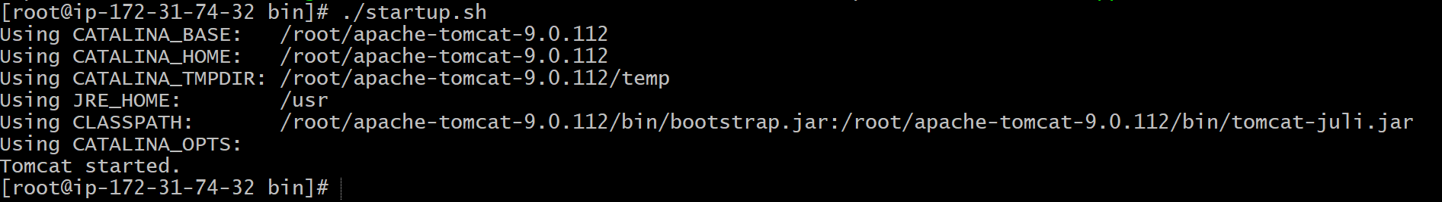
Step 8: verify on web
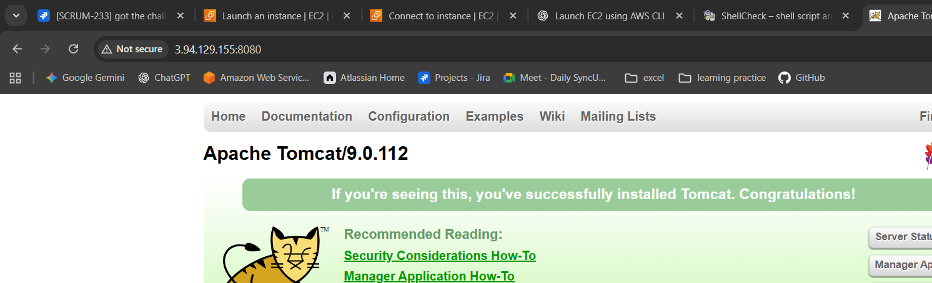

- Changing the apache tomcat port number
Step 1: command vi /root/apache-tomcat-9.0.112/conf/server.xml to 8080 to 8081
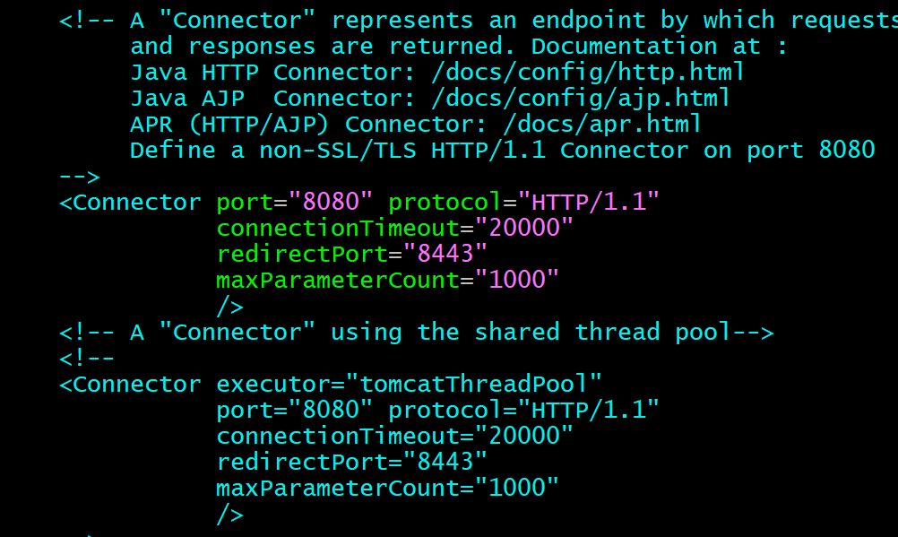
Step 2: after saving shutdown the service and start the service
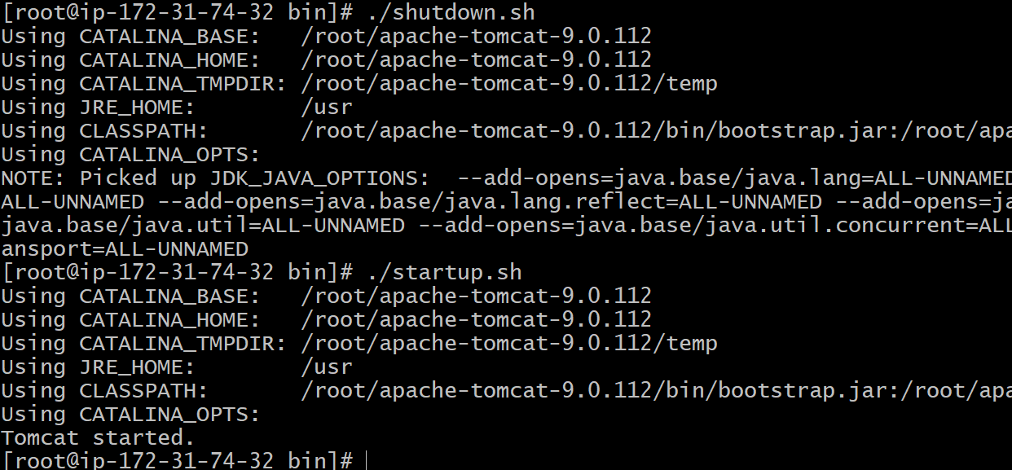
Step 3: verify on web
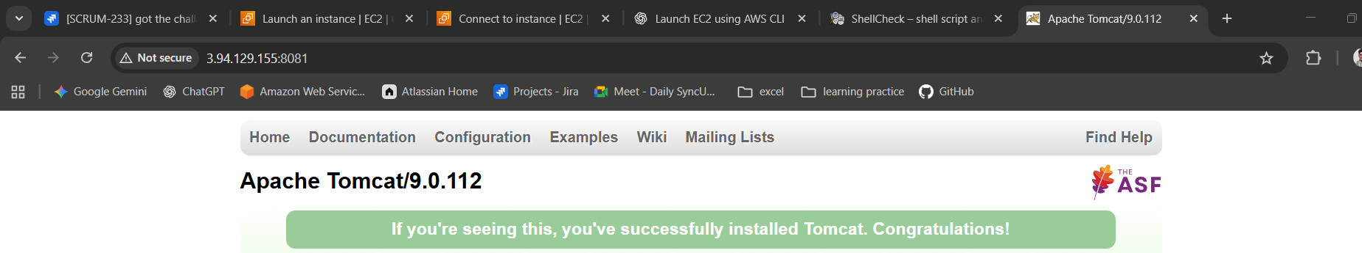
- Install Jenkins
Step 1: copy the link from Jenkins website and use wget to download the package
sudo wget -O /etc/yum.repos.d/jenkins.repo \
https://pkg.jenkins.io/redhat-stable/jenkins.repo
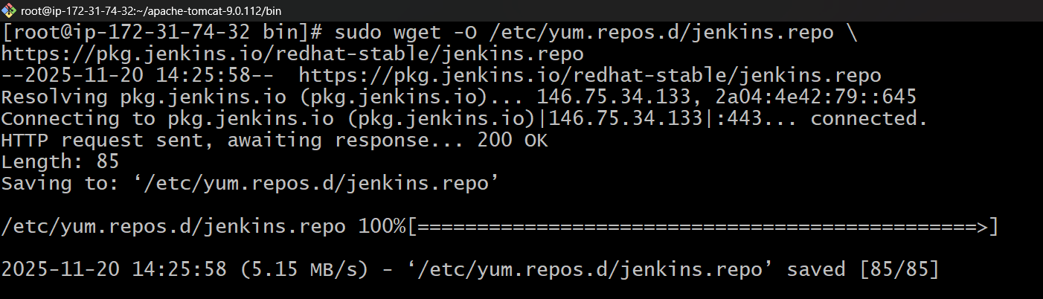
Step 2: import the Jenkins key from website and paste
sudo rpm --import https://pkg.jenkins.io/redhat-stable/jenkins.io-2023.key
Step 3: use command yum install Jenkins -y
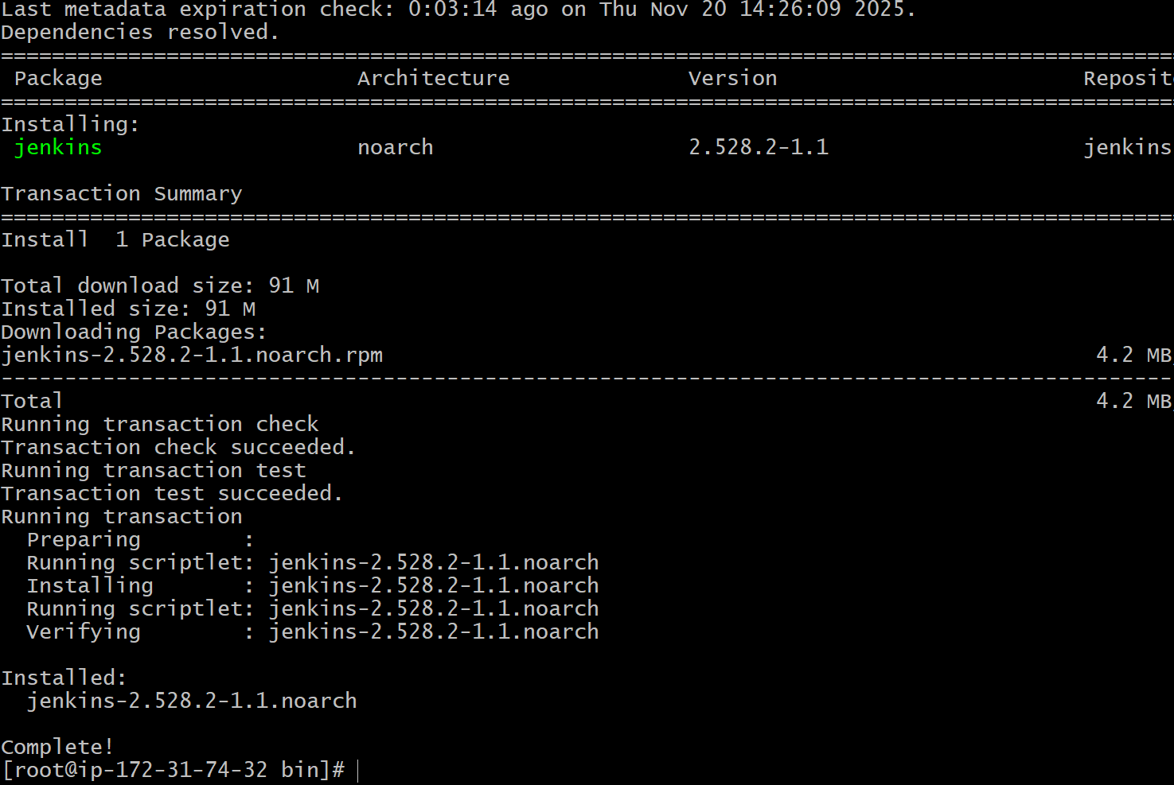

Step 4: start the service using systemctl command
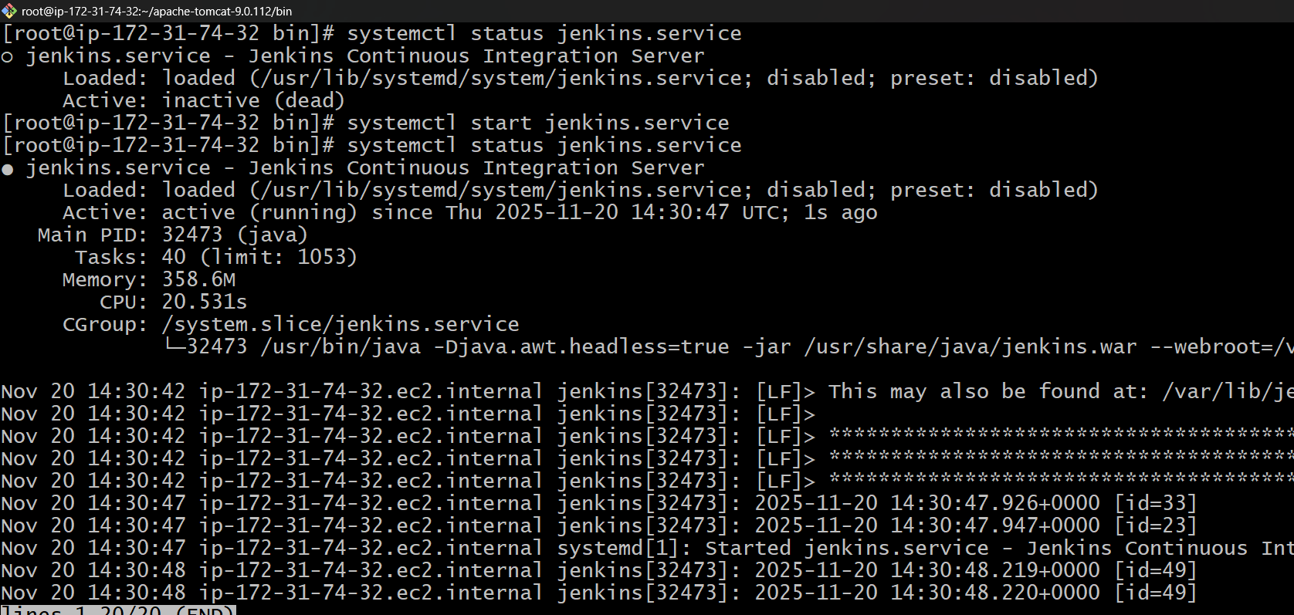
Step 5: verify on web browser
Step 6: asked for administration password
Available at /var/lib/Jenkins/secrets/iniptialAdminpassword
Cat to copy the password and paste

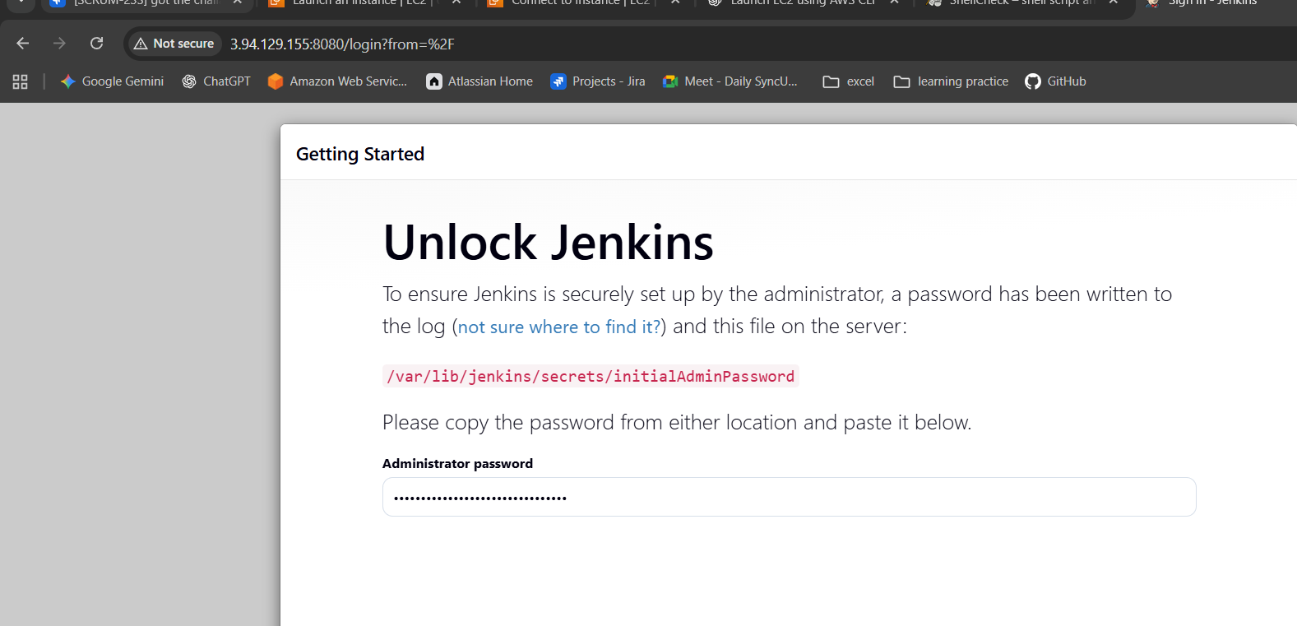

Successfully running the Jenkins application
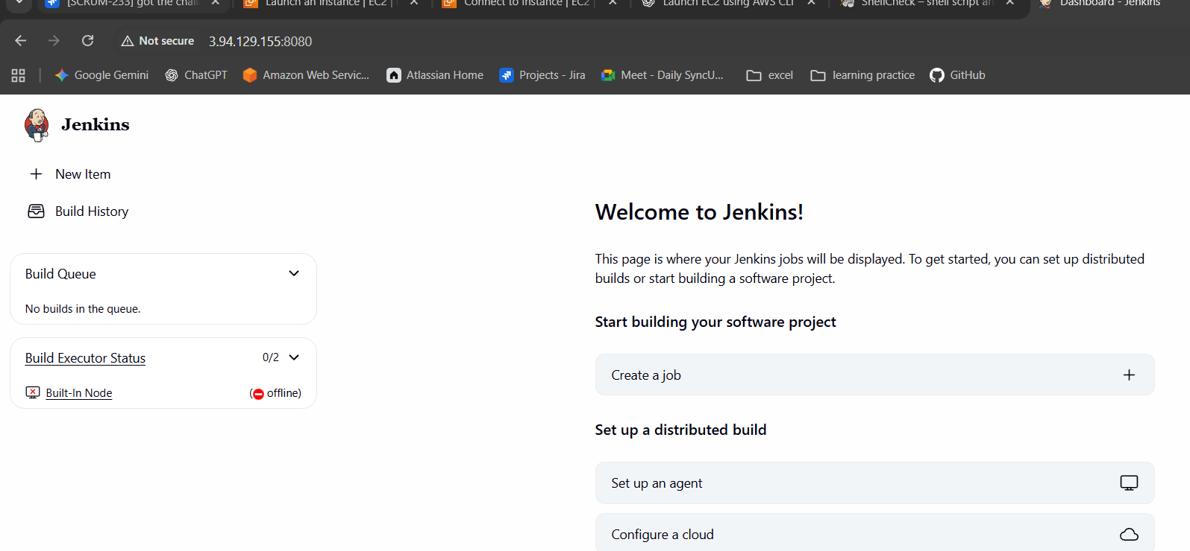

**** port number is changed because of having same ports for Jenkins/Apache tomcat and same for httpd/nginx so that I changed to 80 -81 and 8080-8081

